**Lab 5: Full bit Adder**

Freddie Boadu

ECEN 328

Mansi Bhavsar

March 28,2019

**Introduction:** The overall objective/purpose of this lab is getting comfortable with the application and use of a full bit adder within the program. The students are introduced to the idea of a carry in bit. The carry in bit is added to N bit of numbers and can alter the sum and create a carry out bit. For example, for a 2-bit adder we get a truth table along of the lines of this:

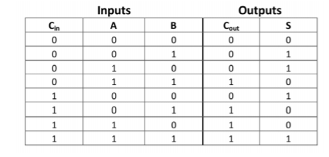

The Boolean algebra equation for this truth table comes out to be:



This extends to 4bit adder which was completed during this lab.

**Materials:**

* Xilinx ISE software, student or professional edition V14.7
* PC with Pentium III or higher, 128+ MB RAM and 8+ GB hard drive
* Digilent Basys2 board with an XC3S100E device.

**Methods:**

The student was asked to created a new project. The project was named FA_1bit. The student was asked to complete the schematic for a 1 bit adder. Upon completing the schematic the student will be able to complete the truth table and find the Cout and Sum for the circuit. This was all done for section 1. For section 2, a new project is made. The project is named Adder4.For this part of the lab, the student will have to use the previous schematic to create a symbol. The student will remove all buffers, use the symbol wizard, and create a symbol for a Full 1 bit adder. The student is then required to make a 4 bit full adder with the collection of 1 bit full adder symbols created. With buffers included the student can simulate the schematic to the board and fill out the truth table: 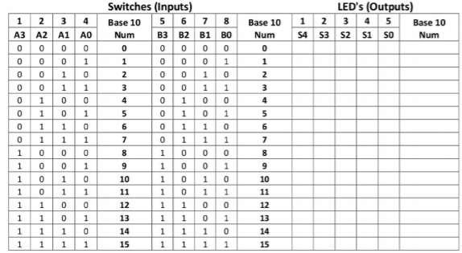

**Data:**

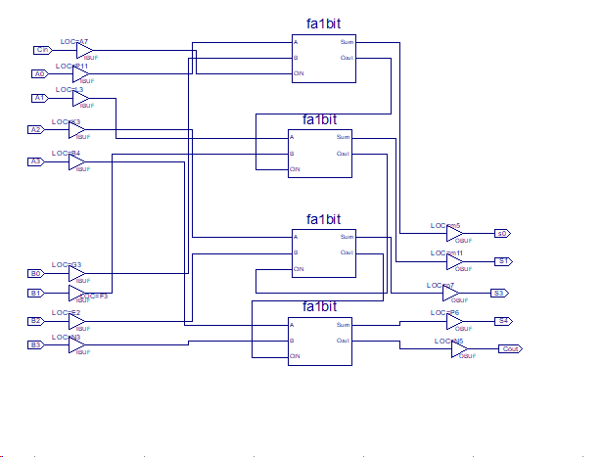

Schematic in section 2

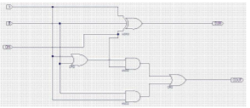

Section 1 schematic

|  |  |  |  |  |
| --- | --- | --- | --- | --- |
| A | B | Cin | Cout | Sum |
| 0 | 0 | 0 | 0 | 0 |
| 0 | 0 | 1 | 0 | 1 |
| 0 | 1 | 0 | 0 | 1 |
| 0 | 1 | 1 | 1 | 0 |
| 1 | 0 | 0 | 0 | 1 |
| 1 | 0 | 1 | 1 | 0 |
| 1 | 1 | 0 | 1 | 0 |
| 1 | 1 | 1 | 1 | 1 |

Section 1 truth table

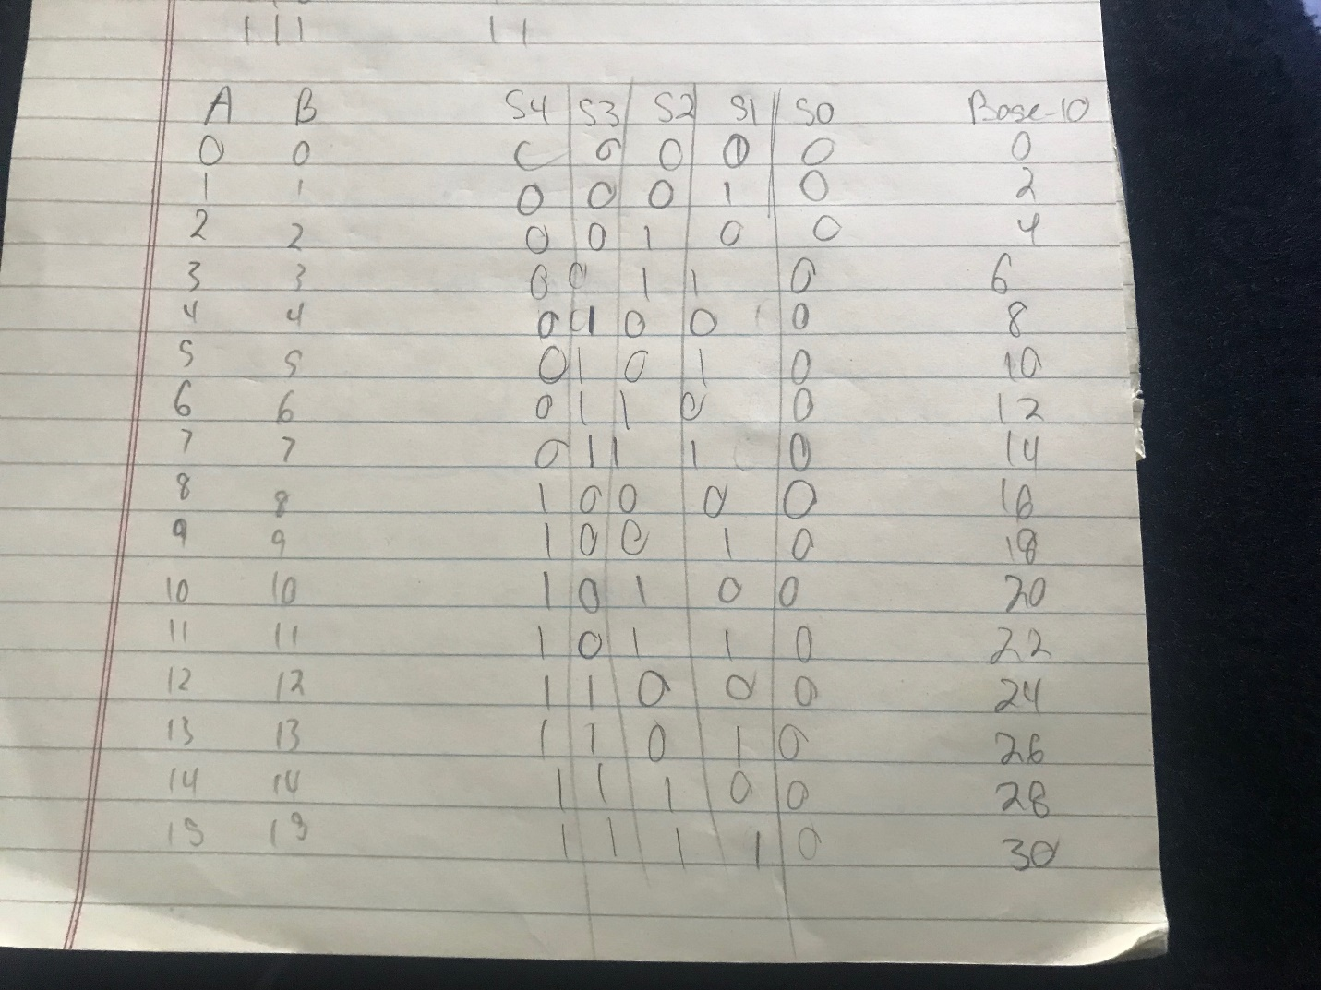

Section 2 truth table

**Results and Discussions:** The schematics are showing the full effect of a full adder in motion. We are seeing from the truth tables that the adders act like regular binary addition. The student was able to see the full effect of a full adder and the combination of their bits allowing you to make larger numbers.

**Design Challenge:**

For the design challenge the student was required to make subtractor using the adders. This was the result of that: 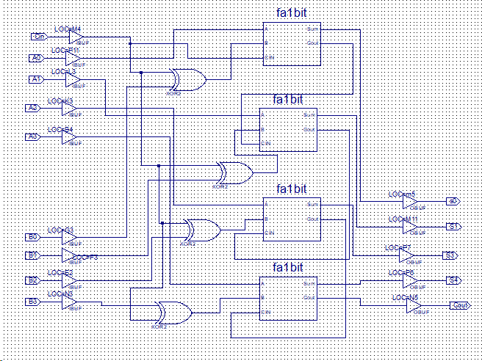

This logic circuit will add two 4-bit signed numbers (A, B) when a control signal (ADD SUB) is HIGH and subtract the two numbers when ADD SUB is LOW.

**Conclusion:** The experiment above shows the use and important of full bit adders. The experiment got student comfortable with using full adders and making sure that the students understood the combination of them.